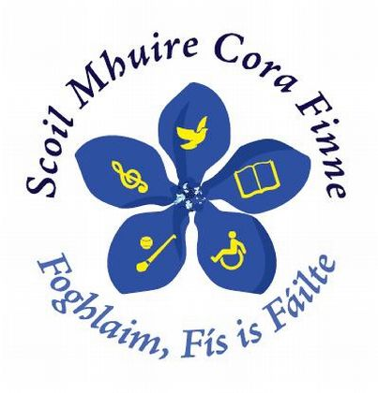 Scoil Mhuire Náisiúnta
Twitter Policy

Who we are:
Scoil Mhuire’s Twitter presence is managed by the school’s staff.
If you follow us, you can expect tweets covering some or all of the following:
- School news
- Upcoming events in the school
- Events of interest to parents/children in the Corofin area

Replies:
We use twitter mainly as a ‘broadcast’ tool to share information with people who are interested in Scoil Mhuire. Unfortunately, we will not always be able to provide replies or other feedback to our followers. Sending a message via Twitter is not considered as contacting the school for official purposes and we are not obliged to monitor or respond to requests for information received via Twitter. The best means of communicating a query to the school is by contacting the school directly on (065) 6837302 or corofinnsclare@gmail.com.
Please do not include personal/private information in your tweets to us.
Availability:
Twitter may occasionally be unavailable and we accept no responsibility for lack of service due to Twitter downtime.
Review:
This policy will be subject to periodic reviews as necessary.

Communication:
A copy of this policy has been given to each teacher and is available for parents to view in the school. The policy is also on our school website.

Policy Ratification:
This policy was ratified by the Board of Management at its meeting held on: ____________

Signed: _______________________________________

(Chairperson, Board of Management)

